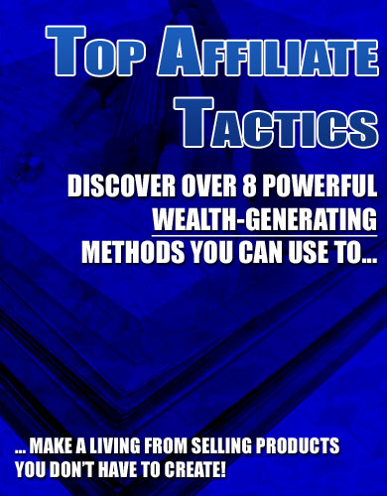

Top Affiliate Tactics

“Discover Over 8 Powerful Wealth-Generating Methods You Can Use To Make A Living From Selling Products You DON’T Have To Create!”

LEGAL NOTICE

The Publisher has strived to be as accurate and complete as possible in the creation of this report, notwithstanding the fact that he does not warrant or represent at any time that the contents within are accurate due to the rapidly changing nature of the Internet.

While all attempts have been made to verify information provided in this publication, the Publisher assumes no responsibility for errors, omissions, or contrary interpretation of the subject matter herein. Any perceived slights of specific persons, peoples, or organizations are unintentional.

In practical advice books, like anything else in life, there are no guarantees of income made. Readers are cautioned to reply on their own judgment about their individual circumstances to act accordingly.

This book is not intended for use as a source of legal, business, accounting or financial advice. All readers are advised to seek services of competent professionals in legal, business, accounting, and finance field.

You are encouraged to print this book for easy reading.

Table of Contents

Top Affiliate Tactics: Introduction 5

Using Classified Ads 5

Leveraging with E-zine Advertising 7

Solo Ads – Outmoded or Back in Style? 8

The Cheapest, Fastest Way to Advertise on the Internet: Forum Posting 10

Using Traffic Exchanges to Promote Affiliate Programs 11

Social Networking Sites For Affiliate Marketing 13

Generate Traffic and Affiliate Sales with Free Viral Reports 15

Build Your Own Mailing List… Even Though You’re an Affiliate! 16

In Closing 18

Recommended Resources + Bonuses 19

Top Affiliate Tactics

Top Affiliate Tactics: Introduction

Hi and welcome to Top Affiliate Tactics, where you will discover over 8 powerful methods you can use to offer a boost to your affiliate commissions from selling other people’s products and services.

This guide discusses some of the methods you’ve probably not heard of, whereas other methods you’ve thought would never work. In a real essence, it’s really only a matter of doing it right and you can make a living off affiliate marketing.

Which is really fascinating, because you can earn big commissions just promoting products you DON’T even have to create!

Of course, like everything else in life, it takes multiple practices to reach the top level. But I assure you that through the coming pages, I can help you reduce your learning curve significantly and you will make less guesswork… and mistakes!

I have written this book as short and precise as possible. Because I know you’re a very busy individual (and it takes no guess), and above all, I also know that you’re excited and that you can hardly wait. ☺

Without further ado, let’s quickly cover the first of the 8 methods you can use in boosting your affiliate promotion… and the commissions!

Using Classified Ads

The process of using classified ads to generate sales for any product – whether it be an original product or an affiliate product – is often over-simplified and discouraged. This is, in part, because it actually is one of the harder ways in which you can advertise.

It requires you to use a small amount of words to communicate an important point, which will either make or break your ability to garner interest in the product in question. In most cases, supposed experts will discourage you from using classified ads because they themselves have never had much luck using them – NOT because classified ads aren't a viable method of advertising.

So how can you use classified ads correctly to generate a considerable amount of traffic to your affiliate product sales page?

The first step entails finding viable places to advertise. Again, many of the so-called experts will jump in and either tell you to use free sites or that free sites never work. The truth here, too, is somewhat in between: free sites can work, but you must use them carefully. For instance, if you want to generate traffic from sites that allow you to post free classifieds, you will have to find ones that actually receive traffic themselves.

One example of a site that receives a massive amount of traffic, but also allows you to post classified ads for free is craigslist, which you can find at the following URL:

http://www.craigslist.com

As long as you post classified ads in the proper section, you can do it completely free of charge. Additionally, you can do this on each of the craigslist sites for the metropolitan areas in the United States.

Another place you can post free classified ads is Yahoo. You can find this feature at the following URL: http://classifieds.yahoo.com/.

Again, as long as its on topic, you can post a classified at for whatever you want.

Now, with this in mind, you will want to consider the best way in which you can construct your classified ad. I personally suggest creating a headline or first line that uses psychological triggers.

Remember! With classifieds, you're not paying by the click. It's either free or you're paying for a certain period of time or impressions, so your goal should be to generate as many clicks as possible, so use words like “cheap,” “free,” “proven,” and “shocking” to draw attention to your ad.

Once you have successfully drawn attention to your ad through the headline, you will then want to seal the deal by providing viewers with a reason to click through, provided that your affiliate product is something they will want to buy. You can do this by explicitly stating a quantifiable benefit in the second line of the classified ad – and then stating a crucial feature in the third line.

Once you have gained some experience posting ads on free classified ad mediums, you will want to move on to major electronic publications, including large e-zines and authority sites; however, before you do this, you could be confident in the classified ad and your conversion rate.

Leveraging with E-zine Advertising

Warning! If you're ever bored and want to stir up some trouble, go to an Internet marketing forum and post a question asking how well E-zine advertising fares in comparison to other marketing methods.

The answers you get are likely to be diametrically opposed. This is not only because each marketer has his own product to sell – and it is in his best interest to justify the purpose of that product – but it is also because there has been a genuine debate raging for the past few years about the effectiveness and direction of E-zines and E-zine advertising.

There are those who posit that E-zine advertising is dead or is near the bottom of a very steep decline. They see the average person as being overwhelmed by superfluous emails on a daily basis – some coming from friends and others coming from businesses and E-zines.

In their eyes, this amounts to a continuing decrease in attention paid to any emails that look business related, even if they specifically subscribed to them.

Additionally, they argue that many people forget that they joined lists and eventually begin to ignore emails coming from that address. And all of this is true – which is precisely why it is important to take it into consideration when you are conducting E-zine advertising campaigns.

So how can you affectively advertise in E-zines and reap a profit from affiliate products?

There are a number of different ways, of which, I will cover three below:

1. Target E-zines that are related to your specific affiliate product.

Create a viral report that is related to your affiliate product (as we discussed in the previous lesson). Purchase sponsor ads in reputable E-zines – and send all of those interested to a page where they can download your viral report for free. This report will have an embedded affiliate link, which will generate sales on your behalf.

2. Create a persuasive solo ad.

Again, start off by purchasing solo ad space in cheaper E-zines – ones that are responsive, but have a low subscription count. Test your solo ads to determine your approximate conversion rate with the given affiliate product. Once you have a rough handle on your profit margin, attempt to market your solo ads in larger publications, including e-zines with subscriber bases of over 100,000. Keep in mind that this will be expensive, but it will also pay off if you did your homework in the previous steps.

3. Last, consider targeting high-end online publications with your ads.

These will include ones that don't normally include their sites in E-zine directories, such as authority sites that publish a monthly E-zine in PDF format. These often have high response rates and will similarly draw the best response if you use them correctly.

For regular E-zines with reasonable fees, you will want to check out the following site, which lists most E-zines that offer advertising:

http://www.E-zineadvertising.com/cgi-bin/pz.cgi

If you're looking for something less expensive, you may want to check out the following URL:

http://www.E-zinead.net/
http://www.ezines-r-us.com/

Solo Ads – Outmoded or Back in Style?

Now we're going to go over solo ads:

For years, Internet marketers have asserted that solo ads are simply outmoded – they're a dinosaur that no longer has the potential to reap any profits; however, another group of Internet marketers knows that the exact opposite is the truth: solo ads can reap massive profits, but in order to do so, they must be engineered perfectly, as must the selection of the solo ad distributor.

A solo ad can be a number of things. Usually, it is a large ad between 200 and 300 words that is placed at the very center of a page. The rate on solo ads is higher than on all other potential options, but it also captures readers' attention the most by far. If you have the money to spend on a solo ad, it can be an excellent investment.

However, as with all investments (and advertisements for that matter), you must conduct your due diligence. This involves a considerable amount of research.

Now, when conducting research for a solo ad, there are two things you will want to look at:

- The first is a list of your potential advertising outlets (in this case, probably e-zines); and
- A list of potential approaches you can take on your solo ad.

Let's start with the first part – finding a list of e-zines in which you can put a solo ad. I personally suggest starting with Directory of E-zines, which you can find at the following URL:

http://www.directoryofE-zines.com/

This is the ultimate resource for advertisers who want access to all e-zines and also want tips for advertising in them. If you don't have any money to spend, I would suggest starting here instead:

http://www.E-zine-dir.com/

Once you have selected reputable e-zines to advertise in, you will then want to begin creating your solo ad. There are a number of writing “formulas” you can use to do this; however, you will always want to keep in mind what it is that your potential customer wants most.

In advertising, it is often easy to project our own wants in a given product onto potential buyers; however, it is important – when communicating with them – that you talk about their wants, not yours.

Now, when it comes to creating solo ads, I personally suggest that you spend some time at the following URL, learning about what it takes to convert readers into buyers: http://www.copywritersboard.com/.

Furthermore, I suggest that you go beyond simply writing copy and write as you would in the specific medium. For instance, if your solo ad will be featured in an e-zine, then you will want to write as if you are contacting members of a mailing list about a special offer or something similar. You may even want to refer to the owner of the list by his/her first name if (s)he allows that.

Keep all of these skills in mind when conducting solo ad campaigns. All you have to do is select the right advertising mediums and create an excellent ad – and your effort will pay off three fold.

The Cheapest, Fastest Way to Advertise on the Internet: Forum Posting

Posting on forums is one of the cheapest and fastest ways in which you can advertise affiliates products on the Internet. However, in order to do this successfully, you must do a number of things carefully.

Warning! Simply starting a thread that contains an affiliate link might be a good way to get banned from a particular forum board, but it will never be a good way to make sales.

The general procedure involves making multiple posts on a forum board before you even setup a signature file, which includes a link to your site. Even if the particular forum you are using does not specifically mandate this, you will want to do this, anyway, as it will increase your credibility – which is your real goal.

You can start by finding a number of forums for your particular niche or marketing angle. You can find massive lists of forums at the following two URLs:

http://www.big-boards.com/

http://board123.com/forum_directory.php

The first resource is currently the largest forum directory on the Internet. The second resource contains lesser directories, but includes some that are not listed on Big Boards.

Now, once you have selected a number of directories that match your specific marketing angle and affiliate product, you will want to investigate to determine whether or not they have excess rules regulating signature files.

For instance, some sites do not allow any links in signature files; others, by contrast, allow links, but do not allow any commercial links. Make sure you know what the rules are before you post. Otherwise, you are simply setting yourself up to be banned from the forum.

Next, take the list of forums you have created – that are both relevant to your topic and allow commercial links – and begin developing a reputation on those forums. Post regularly, avoid meaningless fights and flaming, and contribute useful, on-target information to discussions. In a matter of 1-2 weeks, you will have developed a reputation, provided that the forum receives a considerable amount of traffic.

Once you have developed a good reputation, you will want to begin advertising through your forum signature. Ideally, you will want to include some eye-catching assortment of colors, symbols, and words in your signature.

This will draw people's attention. You will then want to link them to something other than an affiliate page – whether it be a page you created to sell an affiliate product or an auto responder course used to capture email addresses.

Remember to repeat this process in all applicable forums. Look for high traffic forums that allow commercial link posting in signature files – and that also happen to fit with your specific audience-targeting and marketing angle goals.

Next, create a reputation. Last, add your signature in some attractive way that draws visitors' attention, but is also likely to convert them into interested clickers. You will find that this form of advertising pays off considerably – and does so faster than other methods available.

Using Traffic Exchanges to Promote Affiliate Programs

If you're unfamiliar with exchanges, you will want to read this over carefully and consider printing it out:

One of the best ways in which you can promote affiliate programs is through various traffic exchanges. Almost all well-defined, robust niches on the Internet have some form of traffic exchange. For instance, casinos, gaming sites, niche forums, and Internet marketing sites all have some form of traffic exchange system. IM, in particular, has dozens of exchanges.

A traffic exchange can serve multiple functions; however, in most cases, it does two important things:

- It allows you to surf sites, gain credits, and then cash in those credits; and
- It allows you to put banners or dynamically-generated link boxes on your site that will generate credits, which you can then cash in. Cashing in credits, with most exchanges, results in a certain amount of traffic being drive to your site via the exchange site or via banners on other sites that are members of the exchange.

A good place to start when working with traffic exchanges is to determine which ones are most reputable and which ones have reasonable point systems. For instance, some traffic exchanges allow users to cheat and some have bad systems of exchange, which heavily favor paying members over non-members. You will want to find the best possible exchange given the amount of money you are willing to spend and the product you are marketing.

I suggest using the following sites, which list top traffic exchanges. Additionally, you may want to talk to friends to see if any particular exchange has worked well for them:

http://www.paramind.net/paramindtrafficexchanges.html

http://www.trafficexchangelist.com/

Once you have selected an optimal exchange, you will want to determine the best way in which you can use it to maximize the amount of high-quality traffic you extract from it.

You will want to answer the following questions to aid yourself in determining this: do I earn credits from impressions or clicks? And do I lose credits based on impressions or clicks?

This is important to ask, as different exchanges have different policies on this issue. If you lose credits based on impressions, you will want to make sure that you get the absolute largest amount of clicks per impressions. This will involve over-hyping your ads and creating flashy banners (if they allow them).

In contrast, if you are getting charged per click, you will want to make sure your ads ONLY appeal to the most interested buyers. Whichever route you take, make sure that it is matched up with a model for maximum revenue generation.

The last thing you will want to consider when using a traffic exchange is precisely what you should promote.

You already have a product in mind – probably an affiliate product – but how will you promote it?

Will you direct visitors to the affiliate page?

Will you direct them to a page on your site, which features the product?

Or will you direct them to an opt-in form, which will capture their information and then coax them into buying over a period of time?

I personally suggest doing the last or the second – and avoiding the first whenever possible.

Social Networking Sites For Affiliate Marketing

You might not know this, but social networking sites aren't just for teenagers anymore. In fact, social networking sites have evolved into something different altogether than what they once were – networks composed mainly of teenage girls.

Today, social networking sites span the spectrum of demographic groups. While teenagers are still more apt to use them than older people, there are now niche social networking sites, which target people who all share some common interest, such as a skateboarding or investing.

Now, in addition to teenagers and adults, social networks are increasingly becoming used by another group – businesses. That's right: many businesses are now infiltrating social networks to advertise in some subtle manner – and then replicate their message through systems that are already available within the social network.

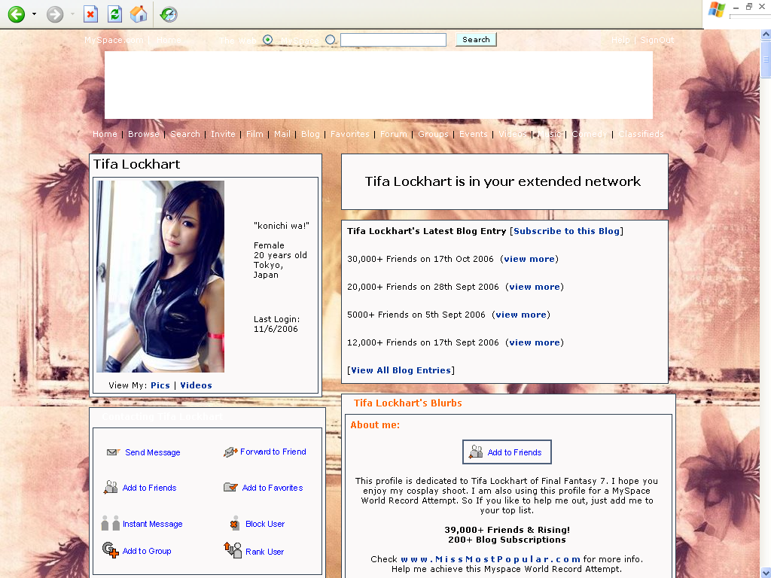

The most prominent social network is http://www.MySpace.com, which boasts a membership base of 1.06 hundred million (and still growing!).

If the affiliate product you are selling has a broad appeal, you may want to use MySpace to market your product, as you will be able to reach the largest crowd quickly.

Now, there are a number of different ways in which you can market your affiliate product through MySpace. One way is to setup a profile, purchase what is called an “adder robot,” and then begin adding friends to your list on a daily basis. The robot can add as many as 300 per day without any problems. I recommend http://www.badderadder.com/ for this purpose.

Depending on your goals, you may want to add a personal profile for yourself and then talk about your business/product on your page; or you may want to simply create a profile for your business and use that to market your product.

While you can send out bulletins advertising your product through MySpace, this is generally discouraged by the MySpace staff and could lead to your getting banned. It is probably a good idea to avoid this; instead, post related bulletins that don't advertise your product, but talk about something similar.

This will drive interested visitors to your page, where they can learn more about the affiliate product you are selling. Note, however, that you will have to link to a non-affiliate page, as affiliate links are expressly forbid on MySpace.

Once you have had some experience marketing to the MySpace crowd, you will want to consider looking at other social networking sites.

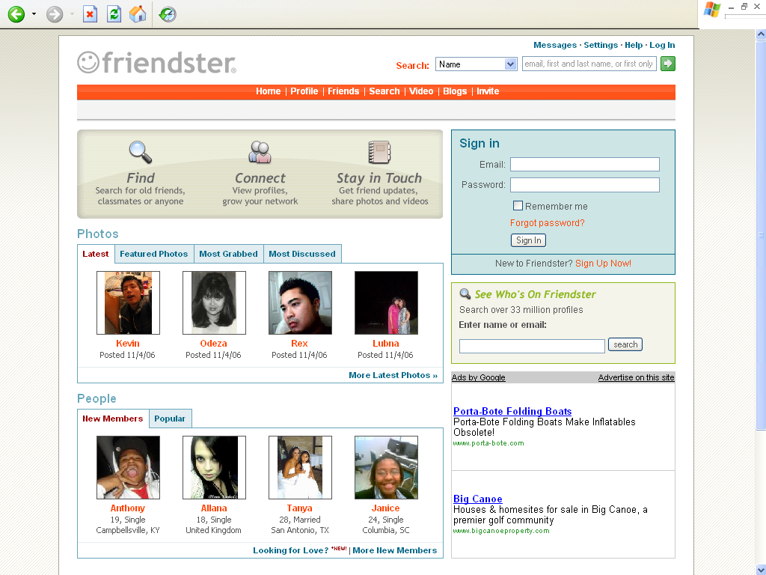

One other large site is Friendster, which you can find at the following URL: http://www.friendster.com. Bear in mind though, that this site is generally very popular in South-East Asia and other Asian countries.

Http://www.facebook.com/ is another large social networking site, which caters specifically to college and high school students. You will also want to look for niche networking sites, which will afford you an opportunity to capture a more targeted audience.

Whichever sites you decide to use, keep the following in mind: your goal should be to develop a network of people who share a common interest and could potentially be interested in your specific product.

For this reason, it is always a good idea to think long term (i.e. don't do things that are going to get you banned); instead, concentrate on building your network and introducing them to your affiliate product.

Generate Traffic and Affiliate Sales with Free Viral Reports

Did you know that the free viral report is quite possibly the most deadly weapon in an affiliate marketer's arsenal?

It allows him o her to quickly multiply his or her efforts while slashing down on marketing costs. All the marketer has to do is develop a viral report for little or no cost, embed an affiliate link in said report, and then find various avenues of distribution that will ensure that the report is perpetuated as far as possible – from group to group to group.

Now, with this being said, when it comes to developing free viral reports, a considerable amount of precise calculation and back-end system setup is needed. Simply jotting down garbage, tossing in an affiliate link, and then attempting to send it to everyone you know in .txt format isn't likely to gain you anything; nor is it likely to multiply your efforts by inducing other marketers to redistribute the report for you.

Instead, you must start from a different point. You must determine what topic people are looking for related to your specific affiliate product.

For instance, do they need more information about the product itself? Do they need to know how to use that product effectively? Whatever your angle happens to be, make sure that it lines up with the wants of your customers and also ties in nicely with your affiliate product.

Next, create the actual viral report and embed your affiliate link in multiple places. If you have a site and a list, you may want to instead post a link to your list – and then use back-end mechanisms to make the sale.

Your last step is to actually ensure that this viral report:

- Gets into as many people's hands as humanly possible; and
- Gets into the hands of people who will definitely redistribute it to others without charging any fees. This is where the art of free viral report distribution comes into play.

A good way to distribute your viral report is to create a buzz on forums. You will want to discuss some specific experience you had related to the topic you will cover in the report – and you will want to do it well in advance of your release date.

You will then want to start talking up your release – and also explain that the report will be completely free. Furthermore, you may want to even start locking people in for immediate distribution via email by getting them to join a list. To learn more about viral marketing through this method, you may want to check out some of the case studies at the following URL: http://www.marketingsherpa.com/.

Additionally, you may want to check out http://www.viralPDF.com, which is an excellent tool you can use to create the actual viral reports.

Once you have begun building a forum buzz for the report, you will want to go to e-zine owners in your particular niche and ask them if they are interested in getting a free report on whichever subject you are marketing. The distribution effect will multiply, subsequently multiplying your sales.

Please note that I will provide a free viral report that you can use to promote my affiliate product. This will cut out the development phase for you.

And the ultimate grand of schemes, which I have purposely saved this method for the last (yet most important!) is:

Build Your Own Mailing List… Even Though You’re an Affiliate!

Today, I want to share with you one of the biggest mistakes affiliates make. I want to share this with you so you wont make the same mistake:

The one major mistake many affiliates make is NOT setting up a list!

Affiliates will often send traffic that they generated to affiliate links, rather than a list. When they do this, they are unknowingly making a bet that visitor will buy on first contact. Unfortunately, this is generally not the case.

Visitors often need to be warmed up to a product – through the course of multiple visits and additional information – before they are willing to purchase from a person or a business. This is where building a list comes into play.

By building a list, affiliates can fix this problem. Additionally, they can retain traffic, warm it up, and then direct it to different purchases in the future. This means that it isn't a one-shot deal: instead, they can attempt to sell the same person multiple products over the course of time.

Now, in order to do this successfully, the affiliate in question must purchase the necessary tools. I personally suggest using http://www.aweber.com for the actual auto responder service.

Aweber is relatively inexpensive ($20/mo.) and comes with a formidable range of services, including spam checkers and macros. Best of all, it is whitelisted by many email clients and boasts a delivery rate of 99%.

This service will not only manage your list, but it will also help you build it. It includes free tools that allow you to create web forms, pop-ups, and hover-ins – all of which can be used to increase your opt-in rate.

Now, in addition to purchasing the auto responder service, you will need to setup your own site if you do not already own one. If you already own a related site, you can simply add your opt in form to a page on your existing site. If not, I suggest purchasing cheap domain and hosting and using this to host your list forms. Http://www.27hosting.com currently offers some of the cheapest hosting available on the market.

Once you have your site and your auto responder setup, there are only two steps left: the first is building a course of some sort that is related to the affiliate products you will sell; and the second is creating an opt-in form that converts.

The first part is relatively easy. Start by determining your topic and then outline it over the course of five to seven days. Remember that everything should be written as if you are talking to a person, rather than as if you were writing a formal article.

If you don't feel comfortable writing these articles yourself, you can always hire a ghostwriter at http://www.elance.com for $5-15 per issue, depending on the size.

Once you have created your auto responder series, you will want to feed it into your auto responder, setup advertisements in the text for the affiliate product you are planning to sell, and then create an opt-in form for your list.

Once you have setup your opt-in form, the only remaining step is to drive various traffic sources to your opt-in list, collect their email addresses – and then wait for the commissions to roll in!

In Closing…

Hi, it’s me again!

As the book draws to a near end, I want to remind you that with the information you now have in your hands, it’s already entirely up to you to put them into practice.

I’ll be the first to say that you shouldn’t expect instantaneous results from getting started right now… or even doing nothing.

At the early chapter of this guide, I’ve mentioned that like any other things in life, affiliate marketing takes a decent degree of practice before you reach the top level.

But one thing is for sure: you now have over 8 fundamental but killer affiliate tactics at your finger tips waiting to be used!

You can use any one or more of them, combine, mix and match… and observe your results in your affiliate earnings!

So all the best in your affiliate marketing journey… to earning an avalanche of affiliate checks!

Recommended Resources

3 Steps to Profiting From Your Resell Right Business – how to profit from buying and reselling digital products in 3 absurdly simple but profound steps, NOT FOUND in most PAID products!

Edmund Loh’s Guide to Private Label Rights v3 – your essential guide to buying and selling Private Label products in the Internet marketplace. This is one of the earliest and often updated manuals on Private Label Rights in the Internet Marketing community!

19 Internet Business Models – eliminate guesswork and discover what makes the world go round for Internet Entrepreneurs and copy their success business systems for your own in a flash – low cost, high profit!

All-in-One E-Commerce Solutions

SOLOBIS – all-in-one solution comes with unlimited web hosting, domain name, unlimited auto responders, broadcast feature, custom web builder, file manager, link cloakers, JV manager, 500+ beautiful web templates, online support team, and many more. No HTML and programming knowledge required.

Recommended Payment Processors

2CheckOut.com – start accepting credit card payments from customers from several parts of the world!

Congratulations!

“Your Purchase of this Book Entitles You to a FREE Lifetime Membership Privileged Access to ResellRightsMastery.com As a Gold Member… Worth $197.00!”



Dear Valued Reader,

I would like to invite you to join my active membership site, ResellRightsMastery.com, as a privileged Gold member! Your Gold member benefits entitle you to:

- Consistently adding collection of Resell Rights items you can sell and pocket all the sales,

- Adding array of Private Label articles you can edit, put in your resource box, compile into Info products, and submit to article directories for exposure,

- Advanced Reseller strategies issues on how to gain all the edges as a reseller,

- And much, much more!

This membership access is valued at $197.00 but as a gesture of thanks for joining me in this short, fast but thrilling adventure through the pages of this book, this membership privilege is yours $197.00 FREE of CHARGE. Consider it a bonus, but you’ll want to be connected to the Internet right now to take advantage of this bonus!

So get connected to the Internet if you haven’t just yet, and click on the link below to sign up – no catches!

Click Here to Join ResellRightsMastery.com as a Gold Member FREE

This is my way of saying thanks and I look forward to your joining in ResellRightsMastery.com! ☺

P.S. Once you’re inside the member’s area, you’ll discover all the possibilities of building your Internet Business on steroids.

